1/1/2019

Kyer Potts

30003389

Web Programming

Project

Table of Contents

**No table of contents entries found.**

# Conversion from Excel Spreadsheet into SQL Scripts

* Spreadsheet was edited to allow for searchedcount column to be entered
* Spreadsheet was then exported to a .csv file
* The following script was then run to create and load data from the .csv file into the table

CREATE DATABASE movies_db;

USE movies_db;

CREATE TABLE movies_table (

`id` INTEGER NOT NULL AUTO_INCREMENT,

`title` VARCHAR(255),

`studio` VARCHAR(255),

`status` VARCHAR(255),

`sound` VARCHAR(255),

`versions` VARCHAR(255),

`recretprice` VARCHAR(255),

`rating` VARCHAR(255),

`year` VARCHAR(255),

`genre` VARCHAR(255),

`aspect` VARCHAR(255),

`searchedcount` INT(5),

PRIMARY KEY (id)

);

LOAD DATA INFILE "C:/xampp/htdocs/Project/movies_with_searchcount.csv" INTO TABLE movies_table

FIELDS TERMINATED BY ','

ENCLOSED BY '"'

LINES TERMINATED by '\n'

IGNORE 1 LINES

(id, title, studio, status, sound, versions, recretprice, rating, year, genre, aspect, searchedcount);

# Project Development Tools

### XAMMP

I will be using XAMPP to host the apache web server that the html and php files will be accessed from.

It will also be used to run the SQL database that contains all the movie information that will be accessed by various functions within the website.

### Web Hosting

The web hosting functionality will be performed by the apache web server component within XAMPP

### Database

The MySQL database component within XAMPP will be used to run the database and process queries from the web application.

## Environment Setup

### XAMPP setup

1. Download the XAMPP client and run setup (the XAMPP client is available at [https://www.apachefriends.org](https://www.apachefriends.org/))
2. Navigate to the installation folder and find the xampp-control.exe executable file. This will launch the XAMPP control panel
3. Start the Apache web server and MySQL database
4. Click the MySQL Admin button to open the phpMyAdmin SQL management interface
5. To access hosted files, navigate to the htdocs folder located within the XAMPP installation folder.

### Database Setup

The following SQL scripts are run to create the movies_db database

CREATE DATABASE movies_db;

USE movies_db;

CREATE TABLE movies_table (

`id` INTEGER NOT NULL AUTO_INCREMENT,

`title` VARCHAR(255),

`studio` VARCHAR(255),

`status` VARCHAR(255),

`sound` VARCHAR(255),

`versions` VARCHAR(255),

`recretprice` VARCHAR(255),

`rating` VARCHAR(255),

`year` VARCHAR(255),

`genre` VARCHAR(255),

`aspect` VARCHAR(255),

`searchedcount` INT(5),

PRIMARY KEY (id)

);

LOAD DATA INFILE "C:/xampp/htdocs/Project/movies_with_searchcount.csv" INTO TABLE movies_table

FIELDS TERMINATED BY ','

ENCLOSED BY '"'

LINES TERMINATED by '\n'

IGNORE 1 LINES

(id, title, studio, status, sound, versions, recretprice, rating, year, genre, aspect, searchedcount);

# Web Application Design Prototype

## Web Design

### index.html

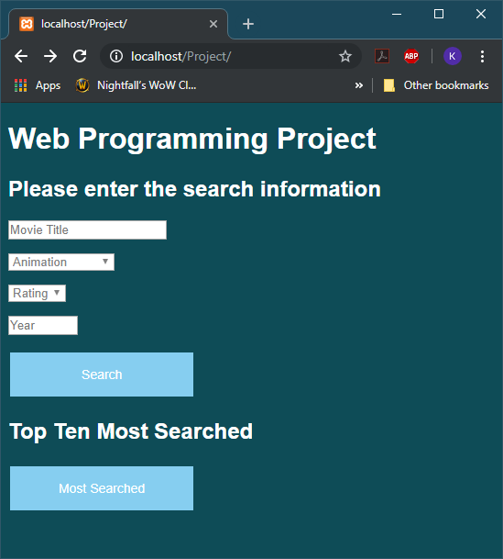

### search.php

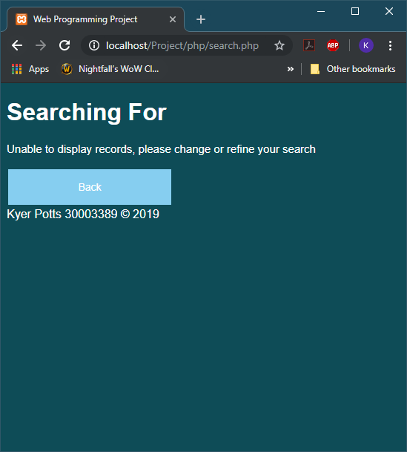

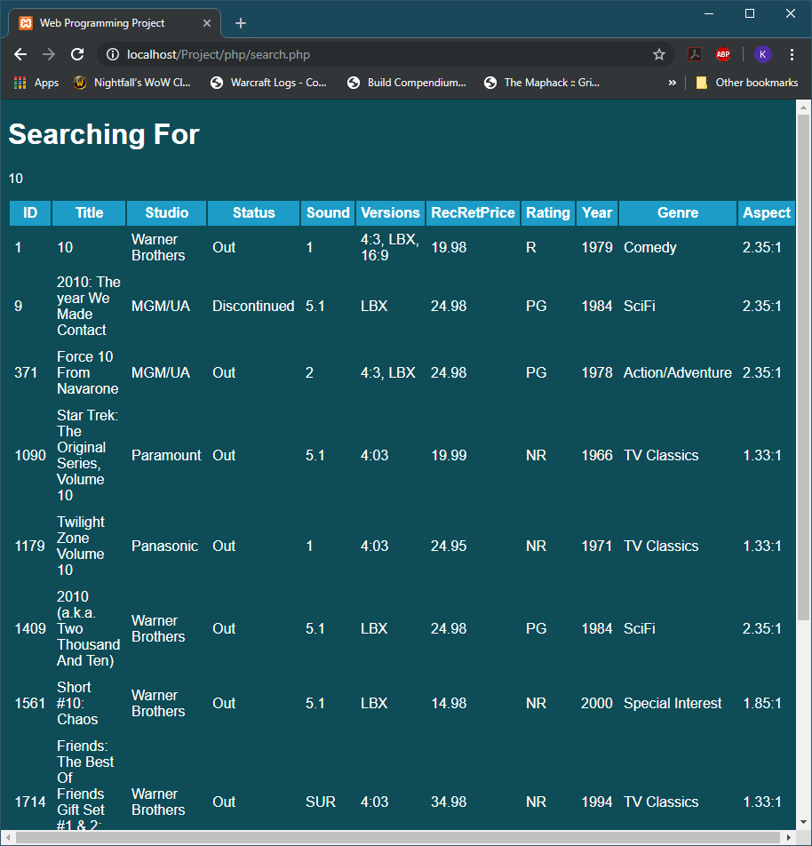

### mostsearched.php

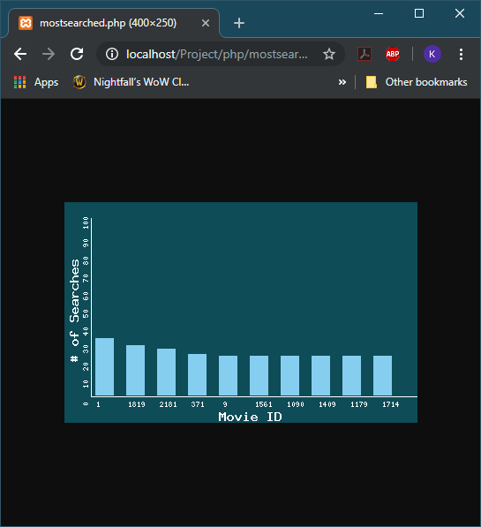

## Database Design

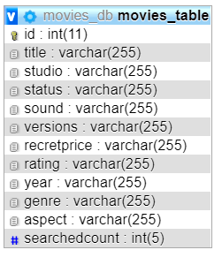

# Test Documentation

## PEAR code standards

PHP Codesniffer was used to identify any code convention errors. The resulting errors were saved into text files within the main project folder, they are named:

* CodeSniffer_connectphp
* CodeSniffer_searchphp
* CodeSniffer_mostsearchedphp

Tools4noobs PHP code beautifier tools were then used to generate fixed code. The files were then saved under the Beautified_PHP_Code folder under the names

* connect.php
* search.php
* mostsearched.php

## Software Risks Analysis Report

### Potential Problems

* User input is larger than the designated number of characters defined by SQL database parameters
* Lack of robust data validation may cause server-side issues with database

### Security Vulnerabilities

* Server password is set to the default password
* Vulnerable to SQL injection
* Vulnerable to PHP injection

# Test Case

|  |  |  |
| --- | --- | --- |
| CASE ID | DESCRIPTION | SCREENSHOT EVIDENCE |
| 1.1 | Web pages open without issues in chrome |  |
| 1.2 | Web pages open without issues in internet explorer |  |
| 1.3 | Web pages open without issues in Mozilla Firefox |  |
| 2. | Drop down functions on index page show appropriate options |  |
| 3 | Search button does not return results if no search parameters have been filled by user. Friendly Error message is displayed |  |
| 4 | Displays all search parameters filled when Search button is pressed |  |
| 5 | Tables fill with correct data when data is retrieved from database |  |
| 6 | Top 10 most searched graph displays data correctly |  |